**Atlantic Salmon Conservation Foundation**

**New Brunswick Salmon Council**

Provincial Symposium

*The path to a healthy and sustainable wild Atlantic Salmon population in Atlantic Canada and in Québec*

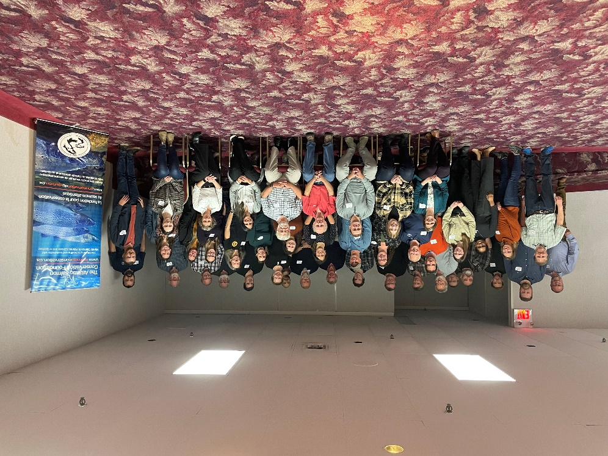

Summary Outcomes from the October 26, 2022 Symposium

Fredericton, New Brunswick

Climate change, escalating human impacts and the critical importance of watershed partnerships dominate discussion at the second provincial symposium in Fredericton, New Brunswick

The Atlantic Salmon Conservation Foundation (ASCF) and the New Brunswick Salmon Council (NBSC) held the second of five provincial symposiums with a large group of diverse and passionate community, research, government, conservation, and watershed management stakeholders in Fredericton on October 26th. Senior policy representatives from the Department of Fisheries and Oceans in Ottawa also travelled to Fredericton to participate in the symposium, leading an interactive session with respect to the elements contained within their draft Wild Atlantic Salmon Conservation Strategy.

Charline McCoy, Executive Director of the ASCF, and Kevin Davidson, President of the NBSC, launched the symposium with a critically important message to the 70 plus attendees - the need for a consolidated approach to wild Atlantic Salmon conservation and watershed restoration efforts. The importance of “*conservation directing funding, not funding directing conservation*” was identified as a key success factor, as well as the need for sustainable partnerships, collaboration, and planning at the watershed level. The symposium was identified as the starting point in establishing a much stronger provincial network and unifying voice focused on wild Atlantic salmon conservation and watershed restoration.

In a strong statement of support and commitment to salmon conservation, the Honourable Mike Holland, Minister of Natural Resources and Energy Development, provided welcoming remarks on behalf of the Government of New Brunswick. Minister Holland shared his family connection to fly fishing and the recognition that wild Atlantic salmon are a key component of province’s rich and diverse outdoor heritage. He reinforced the critically important role of indigenous partnerships, the hard work of provincial natural resource and environmental management staff, and the fact that “*conservation matters*”. He also referenced the significant economic impact associated with recreational salmon fishing and New Brunswick’s protected spaces initiative. He wished the participants a successful symposium and *“tight lines”*.

The morning panel session reinforced the environmental and human impact challenges facing New Brunswick salmon rivers, as well as the on-going need for additional resources and enhanced partnerships and stewardship efforts at the watershed level. Parks Canada, Fort Folly First Nation, the Kennebecasis Watershed Restoration Committee, and the Nashwaak Watershed Association shared successful watershed habitat restoration case studies and best practices. Climate resiliency and integrated habitat management approaches were discussed.

Key themes from the lunchtime keynote address and afternoon panel sessions included:

* **Partnerships & Collaboration**: Symposium keynote speaker Dr. Carole-Anne Gillis, Research Director at Gespe'gewaq Mi'gmaq Resource Council and Member of the ASCF’s Scientific Advisory Committee, reinforced the critically important role of indigenous knowledge, collaboration, and community-based partnerships. “*Place-based approaches*” create successful outcomes.
* **Climate Change**: Climate change, including water flow and temperature, is having a significant impact on the province’s salmon rivers, amplifying human recreational, agricultural, forestry, and industrial impacts. Sedimentation, siltation, and culvert design were identified as key watershed challenges.
* **Science and Data**: Data and applied science is being increasingly used to support effectively decision-making in New Brunswick’s watersheds, including remote sensing, thermal imaging, DNA and live gene banking, proactive life cycle management, and predator species management. New tools and technologies are required to mitigate evolving climate change impacts.
* **Coordination**: Multiple panel representatives discussed the importance of an integrated ecosystem and multi-species approach as key success factors in supporting sustainable watersheds and healthy, long-term ecosystems.
* **Hope, Perseverance & Urgency**: The cumulative challenges associated with sustaining watershed conservation and restoration activities was a common theme (including fatigue and frustration), along with the need for sustainable core and project-based funding for conservation groups and attracting the next generation of dedicated and committed community volunteers. The urgency to act quickly and in in a unified manner was reinforced.

In conclusion, the importance of creating the best possible fresh-water ecosystem for wild Atlantic Salmon was a reoccurring theme, captured by David Dunn and Jim Jones, who facilitated the afternoon panel sessions:

*“We need to protect what we have and restore what we have lost”.*

*“We need to focus on the things we can control, not the things we cannot control, particularly at the watershed level”*

Jim Jones and David Dunn are long-standing ASCF volunteers at the Board and Committee level with extensive conservation management careers – they remain strong advocates for doing everything possible to ensure that healthy fish are leaving our Eastern Canadian salmon rivers.

Key Post-Symposium Action Items

Five key action items were identified by ASCF staff as a direct outcome from the New Brunswick symposium:

1. The opportunity exists to organize future (recurring) provincial symposiums to facilitate the establishment of sustainable conservation partnerships and the sharing of best practices. Alignment of conservation efforts is critical on a ‘go-forward’ basis.
2. There is a strong need for incremental ASCF funding. Discussions will continue with the Department of Fisheries and Oceans (Government of Canada) to double the size of the Foundation’s trust fund, ensuring more sustainable watershed conservation funding in all five Eastern Canadian provinces.

*The Hounourable Mike Holland address the New Brunswick Wild Atlantic Salmon Partnership Symposium*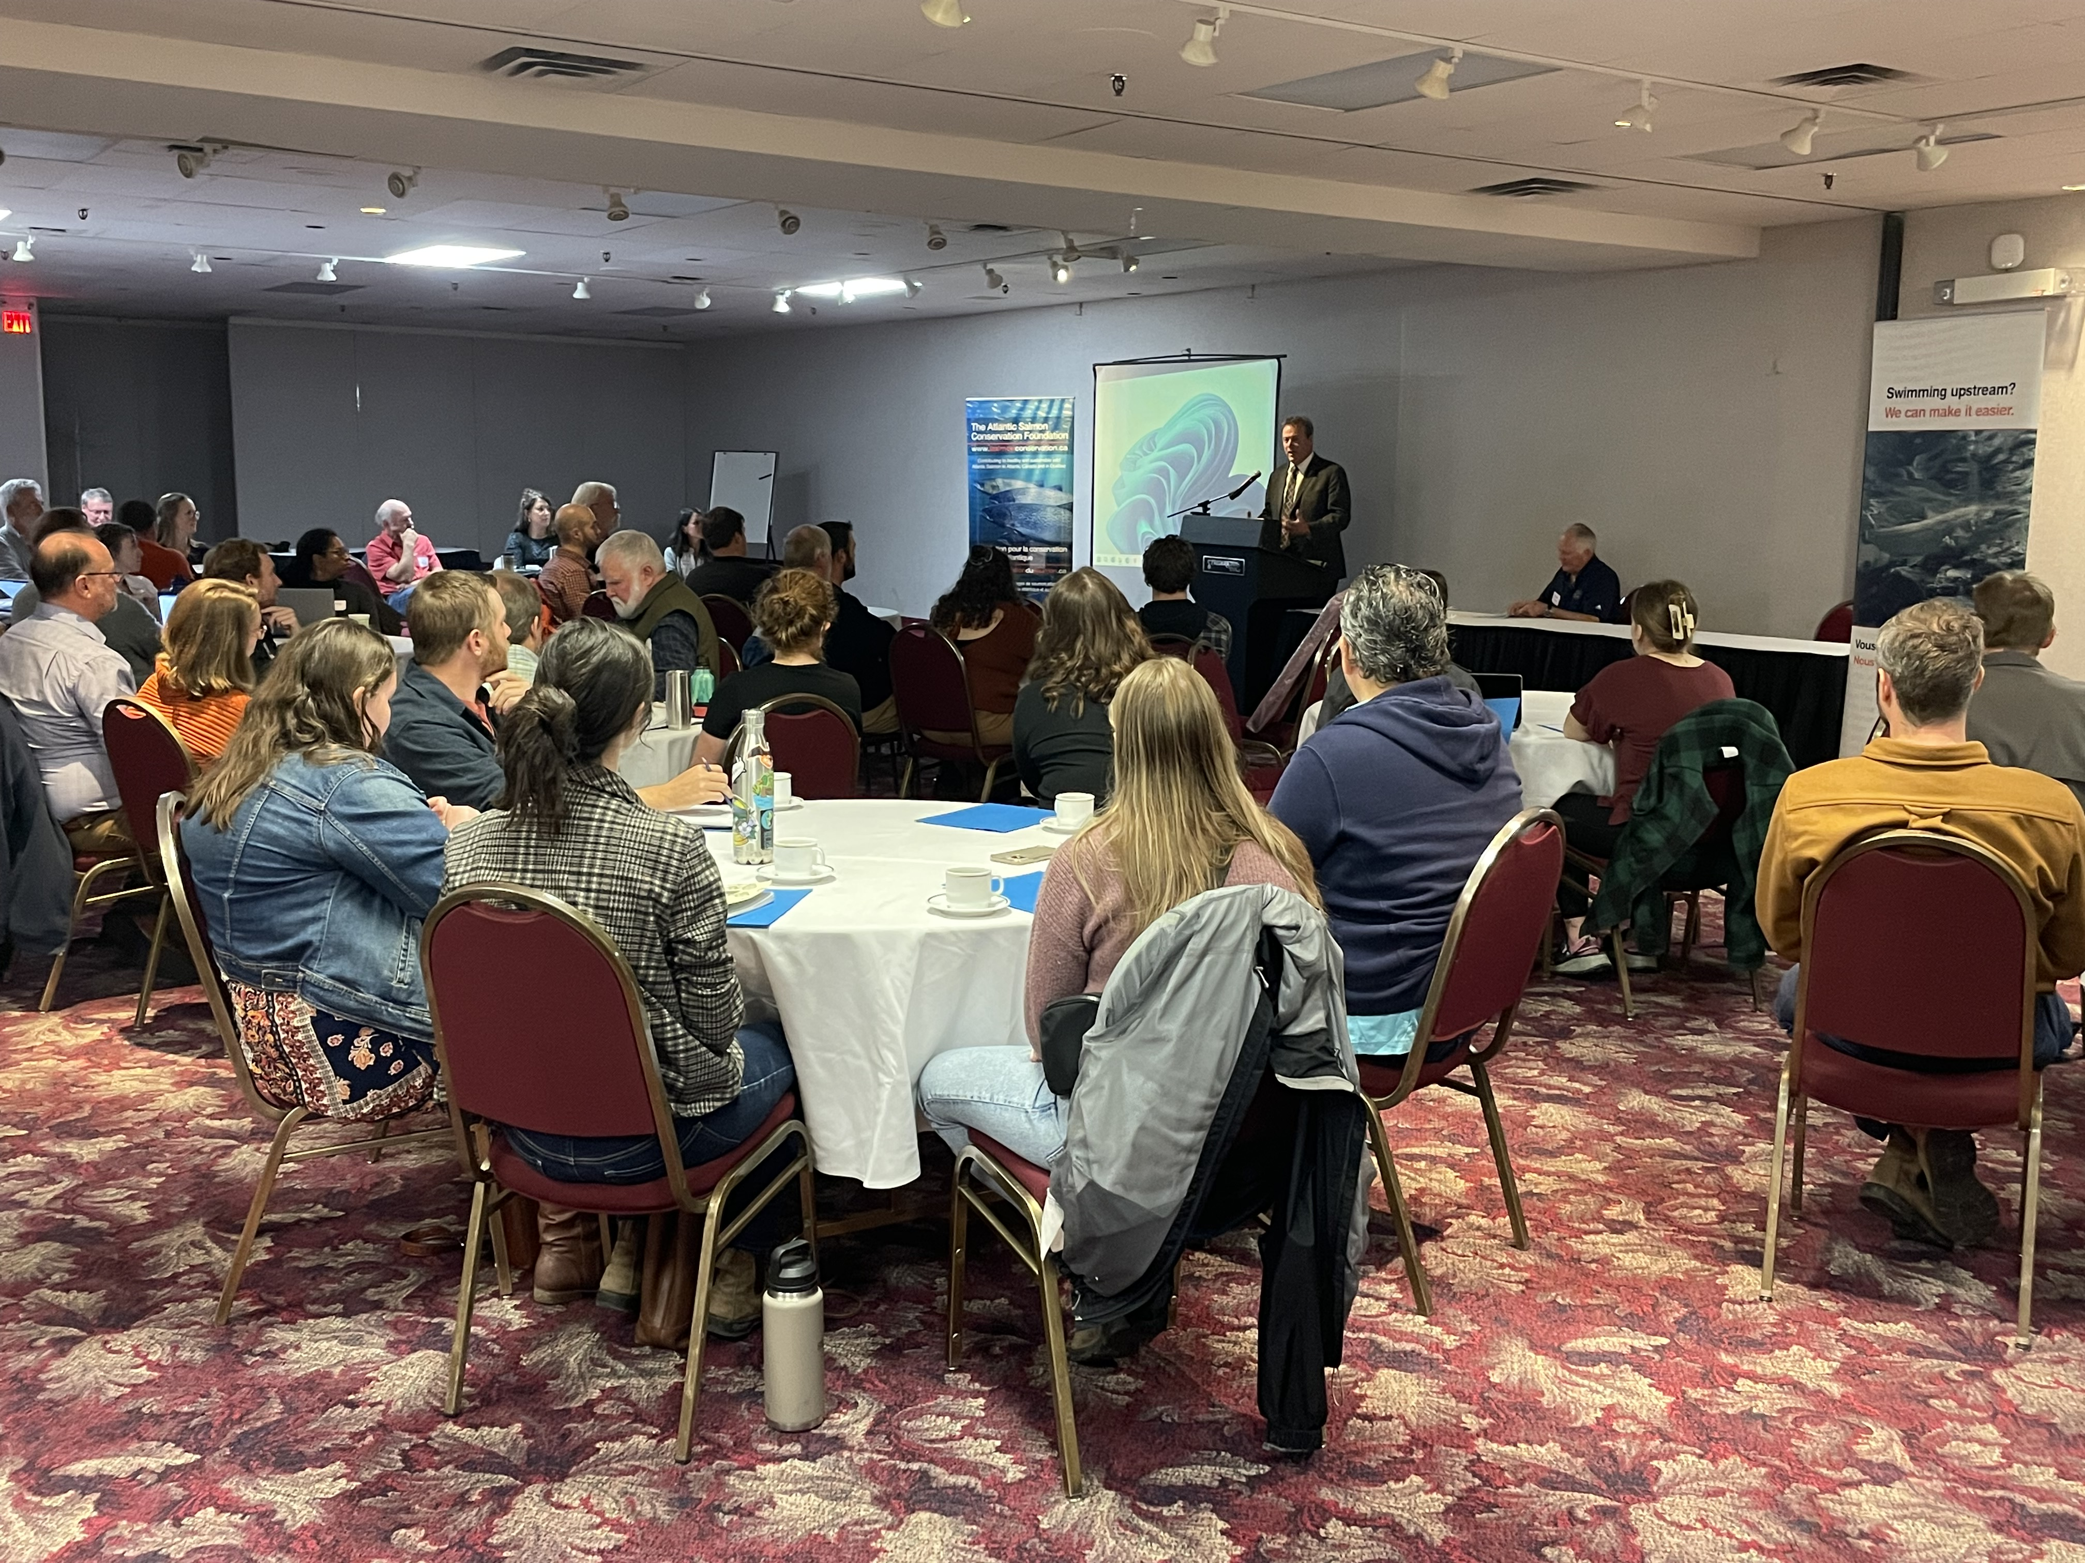

1. It is critically important that the ASCF and New Brunswick salmon conservation community and stakeholders remain actively engaged in DFO’s Wild Atlantic Salmon Conservation Strategy. Local watershed voices need to be proactively heard and listened to in Ottawa.
2. The role of ASCF’s Scientific Advisory Committee and applied science needs to be expanded, with a dedicated focus on information sharing, data sharing, and the introduction of new tools and technologies.
3. There are incredible wild Atlantic salmon conservation and recovery stories that are taking place here in New Brunswick. The ASCF will continue to profile and share watershed perseverance and resiliency case studies with government, the scientific community, and general pubic.

**Attachment A: ASCF Background**

The ASCF, founded in 2007, was established as an endowment fund by the Government of Canada to create lasting financial support for Atlantic salmon conservation projects. Since its inception, it has granted more than $12.5M to 763 projects, including applied scientific research grants and Indigenous-led projects. The outcomes of this work speak for themselves with more than 100 km2 of Atlantic salmon habitat opened or improved.

The ASCF Board of Directors also approved a renewed strategic plan in the spring of 2022 focused on transformational growth. The plan will guide the Foundation’s direction and priorities for the five-year period extending from mid-2022 to 2027, including the goal to double the size of the ASCF’s trust fund and the funds it distributes on an annual basis in support of Atlantic salmon conservation efforts in New Brunswick, Newfoundland and Labrador, Nova Scotia, Prince Edward Island and Québec.

Sixty volunteers representing government, research, academic and several non-governmental organizations from five provinces support the work of the Foundation and are contributing their time and efforts in organizing the five provincial symposiums. The next symposium will be held on October 17th in Charlottetown, PEI.

**The ASCF’s Vision, Values and Mission are well positioned for transformational growth:**

**Vision:**

*To contribute to the attainment of healthy and sustainable wild Atlantic Salmon in Atlantic Canada and in Québec*

**Values:**

*Inclusiveness and Partnerships, Volunteerism, Balance and Integrity*

**Mission:**

*To promote enhanced community partnerships in the conservation of wild Atlantic salmon and its habitat in Atlantic Canada and Québec*

**Attachment B: ASCF Outcomes**

The ASCF has delivered over $12.5 Million in funds to 734 Projects since 2008. Through effective governance, the original $30 million trust fund has also grown to over $46 million.

* 113 million square meters of habitat access opened and 2.2 million square meters of improved habitat.

**Geographic distribution of ASCF funds since 2008:**

* New Brunswick: $3.06 million
* Newfoundland & Labrador: $3.07 million
* Nova Scotia: $1.33 million
* Prince Edward Island: $1.24 million
* Quebec: $2.34 million
* Scientific Advisory Committee: $1.47 million
* 8,989 volunteers contributed 211,822 hours of effort.
* 155,241 individuals involved in education & awareness.
* $1.5 million contributed to 80 Indigenous organization projects.
* $2.5 million contributed to 75 applied scientific research grants, aimed at improving the effectiveness of Atlantic salmon conservation efforts.
* 2,958 jobs sustained, mostly in rural areas - ASCF funded projects help sustain an eco-tourism industry worth several hundred million dollars annually in 5 provinces.
* ASCF funds have leveraged more than $62.3 million in overall project valuation from other sources for an impressive leveraging ratio of 5:1.