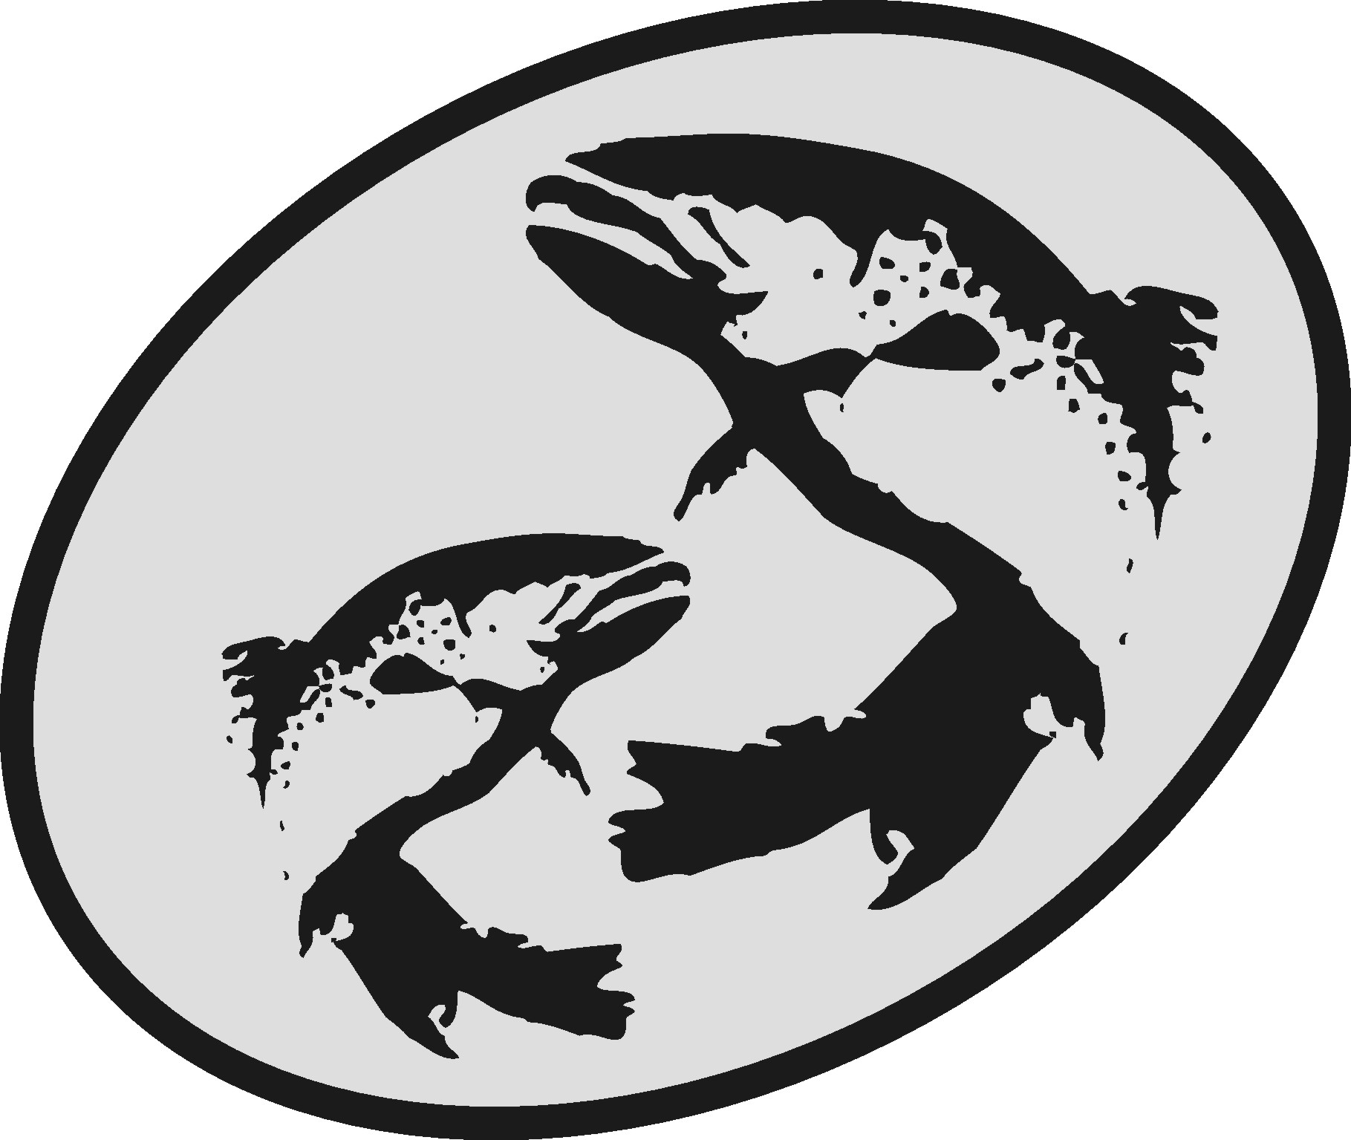
The Atlantic Salmon Conservation Foundation

Progress Report

This form has been developed to simplify the reporting of the progress of your project and must be used for any Progress Report agreed to in Schedule “D” of your Funding Agreement. Do not send the report in any other formats.

The information you provide will be used to document the specific and overall accomplishments of your project and the effectiveness of the ASCF grants and may be subject to audit.

ASCF relies on receiving accurate and transparent information. Per Subsection 2.1(c) of your Funding Agreement, reports must identify any issues that affect or could affect the timely and satisfactory completion of the Project or any other aspect of the completion of the Project which may result in the need to vary the Project.

For projects located in New Brunswick or Québec, or that resulted from an RFP for applied scientific research, please submit your completed report along with an invoice for your progress payment by email to Charline McCoy at: charline@salmonconservation.ca

For projects located in Nova Scotia, Prince Edward Island or Newfoundland and Labrador, please submit your completed report along with an invoice for your progress payment by email to Gert Lawlor at: gert@salmonconservation.ca

Contact us by telephone at 506-455-9900

Section A | PROPONENT INFORMATION

Organization:
Project Title:
Contact Person:
Address:
Phone: | Fax:
Email:
ASCF Grant Amount to date $: | Project costs to date $:

Please list all partners (other than ASCF) that are contributing a confirmed cash or in-kind amount to this project, including the amount contributed.

Partner | Contribution  ($) | Cash or  In-Kind

Section B PROJECT PROGRESS INFORMATION

Project start date: | Target completion date:

- Please describe changes (if any) that have been made in the project or budget since your funding agreement was completed.
- Provide a brief description of the status of the project by reporting on the progress of deliverables and outputs described by the Performance Measures identified in the Funding Agreement, and according to due dates (if due prior to the end of the project). Please attach any documentation to support your work thus far.

Performance Measure  (Use wording from Funding Agreement,  Schedule “A”) | Brief description of results to date.

- Do you expect to complete the project by the due date as set out in the Funding Agreement? (Yes/No)

If No, please explain. (Please limit to 250 words or less.)

Questions and/or Comments

