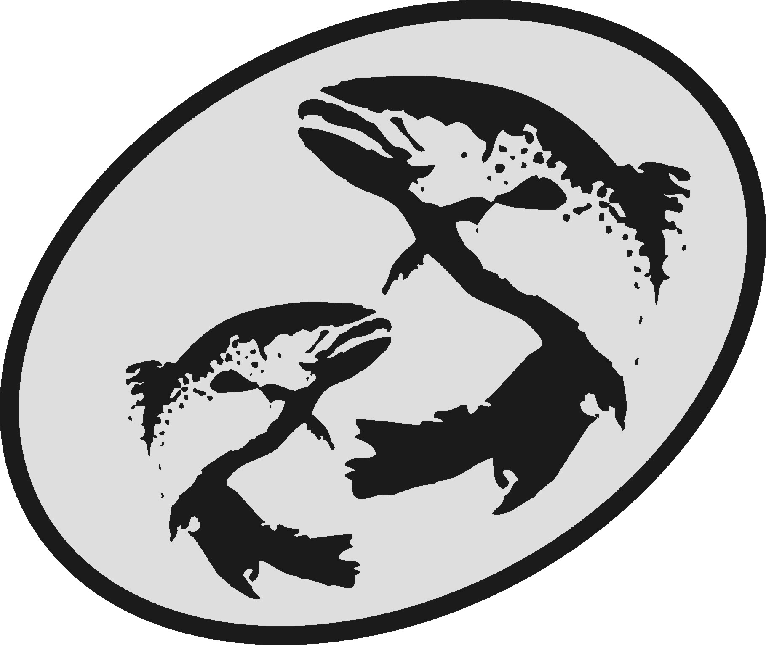 | The Atlantic Salmon Conservation Foundation
 | Final Report

This form has been developed to simplify the reporting of your accomplishments to the ASCF. Please use this form for your Final Report. Do not send final report in other formats.

ASCF relies on receiving accurate and transparent information. The information you provide will be used to document the specific and overall accomplishments of your project and the effectiveness of the ASCF grants and may be subject to audit.

This report is distinct, and may be different, from other final reports you may prepare for your project. The ASCF wishes to receive those reports in addition to this report.

Please note:

- Your Final Report and a statement of expenditures are due on the date provided in Schedule “C” of your contribution agreement.
- Attach copies of receipts for all ASCF funded expenditures.
- Any remaining balance of ASCF grant funds must be returned to the ASCF with the Final Report.
- Do not “refer to attachments” for information requested in this form.
- A final report is required on the date agreed to in your funding agreement. If it is not submitted, future applications to ASCF will not be considered. Amendment of the dates for reporting may be made by mutual agreement

For projects located in New Brunswick or Québec, or that resulted from an RFP for applied scientific research, please submit your completed report along with an invoice for your final payment by email to Charline McCoy at: charline@salmonconservation.ca

For projects located in Nova Scotia, Prince Edward Island or Newfoundland and Labrador, please submit your completed report along with an invoice for your final payment by email to Gert Lawlor at: gert@salmonconservation.ca

Call us at 506-455-9900

Section A: Project Information

Organization:
Project Title:
Year Grant Acquired: |  | End date:
Contact Person:
Address:
Phone: |  |  | Fax:
Email:

Section B: Project Description

Category of Project (check all that apply):
- Development of an Atlantic salmon and salmon habitat watershed plan
- Protection and restoration of salmon habitat
- Rebuilding of stocks and restoration of salmon populations
- Restoration of access to critical salmon habitat
- Education and awareness on the importance of salmon conservation

Summary
Please state the importance, the objectives as stated in your funding agreement and the major results of this project.

Project performance and evaluation:

Please provide an evaluation and assessment of the performance of your project according to the performance measures outlined in the funding agreement. Include problems you encountered and how they were solved, unexpected outcomes, budget inaccuracies, timing changes, and recommendations for future work.

Performance measure  Please take from Schedule “A” of the Funding Agreement | Results

Section C : Project Results

1. Stream(s) or river(s) where project was located :

2. Please provide the following information if it is relevant to your project. Please include only new achievements that have not been reported to ASCF in past projects.

Check | Indicator | Measure | Project Achievement
Development of Atlantic salmon and salmon habitat watershed plan
 | Watershed plans developed/implemented | Number of watersheds involved
 |  | Number of plans
 |  | Km² of watershed area under planning and priority setting
Restoration of salmon habitat
 | In-stream habitat length restored | Length (m)
 | In-stream habitat area restored | Area (m²)
 | Riparian length restored or stabilized | Length (m)
 | Riparian area restored or stabilized | Area (m²)
 | Trees and shrubs planted | Number of trees/shrubs
 | In-stream structures installed | Number of structures
Rebuilding of stocks and restoration of salmon populations
 | Fish tagged | Number of fish tagged
Restoration of access to salmon habitat
 | Restored access to habitat | Area (m²)
 | Debris removed | Tonnes
Education and Awareness on the importance of salmon conservation
 | Type of project | Community stewardship
 |  | Education and awareness
 |  | Volunteer training
 | Target Audience and participants | Number of Grade k-12
 |  | Number of Post Secondary
 |  | Number of Landowners contacted
 |  | Number of audience members at public presentations
 |  | Number of participants at community planning
Other indicators of success
 |  | Value or unit of measure
 |  | Value or unit of measure

Section D: Communications and Media

Yes |  | ______ quantity | No
- Did you use the ASCF logo or sign?
If No, please explain why not:

Yes |  | No
2. Did you provide recognition to the Foundation for its grant?
Please explain the nature of the recognition:

3. Please indicate which communication tools were used to highlight the project as well as the quantity (check all that apply). Be sure to attach any news clippings to the Final Report.

Newspaper |  |  |  | quantity
Interview
Brochure
Website
Other

Yes |  | No
4. Are you submitting a project report (other than this one)?
If yes, please be sure to send the foundation a pdf copy.

5. Did you send your data and results to another organization
Yes |  | No
or data warehouse where people can access the information?
Please state the organizations:

Section E: Human Resources

1. Total number of staff (including students) paid:

through ASCF grant:
through other organizations:

2. Total number of students paid:

through ASCF grant:
through other organizations:

3. Volunteers involved in the project:

Total number of volunteers
Total hours worked

Section E: Statement of Expenditures

Please provide a detailed financial statement of ASCF grant expenditures, in-kind and other funds using the Financial Report spreadsheet.

Be sure to attach copy of receipts for ASCF expenditures only to this Final Report.

Section F: Recommendations to ASCF

To assist us in improving our process, please provide any comments or suggestions you may have on your experience with the ASCF.

