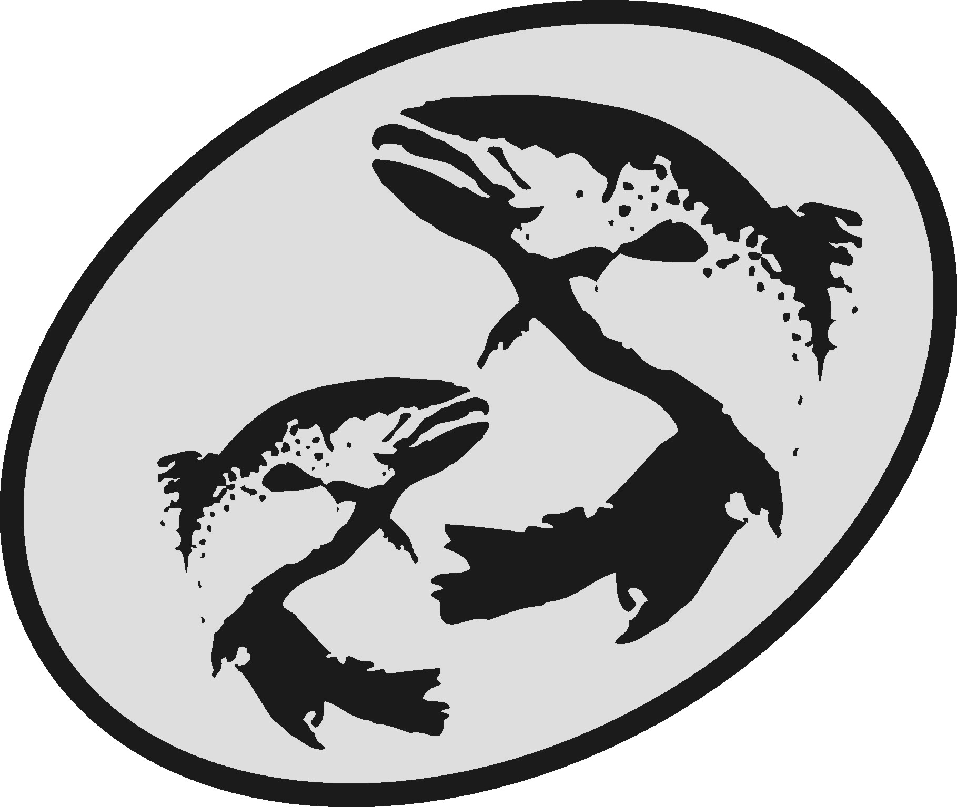The Atlantic Salmon Conservation Foundation

Final Report

This form has been developed to simplify the reporting of your accomplishments to the ASCF. Please use this form for your Final Report, do not send final report in other formats.

The information you provide will be used to document the specific and overall accomplishments of your project and the effectiveness of the ASCF grants and may be subject to audit.

This report is distinct, and may be different, from other final reports you may prepare for your project. The ASCF wishes to receive those reports in addition to this report.

Please note:

- Your Final Report and a statement of expenditures are due on the date provided in Schedule “C” of your contribution agreement.
- Attach copies of receipts for all ASCF funded expenditures.
- Any remaining balance of ASCF grant funds must be returned to the ASCF with the Final Report.
- Do not “refer to attachments” for information requested in this form.
- A final report is required on the date agreed top in your funding agreement. If it is not submitted, future applications to ASCF will not be considered. Amendment of the dates for reporting may be made by mutual agreement.
- Send reports, copies of receipts, photos, maps and final payment invoice to:

darla@salmonconservation.ca (IN, NB or QC projects)
krystal@salmonconservation.ca (NS, PEI or NL projects)
or
The Atlantic Salmon Conservation Foundation
480 Queen Street, Suite 200
Fredericton, NB E3B 1B6
Need help?
For projects that are Interprovincial, in New Brunswick or in Québec, please contact Darla Saunders (Darla@salmonconservation.ca).
For projects in Nova Scotia, Prince Edward Island or Newfoundland and Labrador, please contact Krystal Binns (krystal@salmonconservation.ca).

Office Numbers : Phone: 506-455-9900 Fax: 506-455-9905

Section A Project Information
Year Grant Acquired: End date:
Organization:
Project title:
Contact:
Address:
Phone: Fax: E-mail:
ASCF Grant Amount: $
Section B Project Description
Category of Project (check all that apply):
- Development of an Atlantic salmon and salmon habitat watershed plan
- Protection and restoration of salmon habitat
- Rebuilding of stocks and restoration of salmon populations
- Restoration of access to critical salmon habitat
- Education and awareness on the importance of salmon conservation

Summary
Please state the importance, the objectives as stated in your funding agreement and the major results of this project.

Project performance and evaluation:
Please provide an evaluation and assessment of the performance of your project according to the performance measures outlined in the funding agreement. Include problems you encountered and how they were solved, unexpected outcomes, budget inaccuracies, timing changes, and recommendations for future work.

Performance measure  Please take from Attachment “A” of the Funding Agreement | Results

Section C Project Results

Stream(s) or river(s) where project took place:
Total length (km) of stream if known:
Geographic area inventoried, mapped or assessed (km²):
UTM/GPS coordinates:
If applicable, please provide the following information as they apply to your project. Please include only new achievements that have not been reported to ASCF in past projects.

Check | Indicator | Measure | Project Achievement
Development of Atlantic salmon and salmon habitat watershed plan
 | Watershed plans developed/implemented | Number of watersheds involved
 |  | Number of plans
 |  | Km² of watershed under planning and priority setting
Restoration of salmon habitat
 | In-stream habitat restored | Area (m²)
 | Estuarine habitat restored | Area (m²)
 | Lake habitat restored | Area (m²)
 | Riparian area restored or stabilized | Area (m²)
 | Trees and shrubs planted | Number of trees/shrubs
 |  | Area (m²)
 | In-stream structures installed | Number of structures
 | Non-native species removed | Number of species
 | Other species protected or restored | Number of species
Rebuilding of stocks and restoration of salmon populations
 | Fry released/raised | Number of fish
 | Parr released/raised | Number of fish
 | Smolts released | Number of fish
 | Grilse released | Number of fish
 | MSW released | Number of fish
 | Fish tagged | Number of fish tagged
 | Total fish released | Number of fish
 | Stock assessment | Number of fish
Restoration of access to salmon habitat
 | Restored access to habitat | Area (m²)
 | Debris removed | Tonnes
Education and Awareness on the importance of salmon conservation
 | Type of project | Community stewardship
 |  | Education and awareness
 |  | Volunteer training
 | Target Audience and participants | Number of Grade k-12
 |  | Number of Post Secondary
 |  | Number of Landowners contact
 |  | Number of Volunteers
 |  | Number of Public presentations
 |  | Number of Community planning
Other indicators of success
 |  | Value or unit of measure
 |  | Value or unit of measure
Section D Communications and Media

Yes |  | ______ quantity | No
- Did you use the ASCF logo or sign?
If No, please explain why not:
________________________________________________________________________

Yes |  | No
- Did you provide recognition to the Foundation for its grant?
Please explain the nature of the recognition:
_________________________________________________________________________

- Please indicate which communication tools were used to highlight the project as well as the quantity (check all that apply). Be sure to attach any news clippings to the Final Report.
Newspaper |  | _____________ quantity
Interview |  | _____________
Brochure |  | _____________
Website |  | _____________
Other |  | _____________

Yes |  | No
- Are you submitting a project report (other than this one)?
If yes, please be sure to send the foundation a pdf copy.

- Did you send your data and results to another organization or data warehouse where people can access the information? Please state the organizations:
_________________________________________________________________________

Section E Partner and Funding Information
- Please list all involved partners in the project and their contributions.
Please verify that the total below matches the total presented in Part 5 of the Budget.
Organization name | Type of group* | Description or function of partner | Amount
 |  |  | Cash | In-kind
ASCF | NG | Funding partner
Sub-total
Total (Cash + In-kind Sub-totals)
*Government (g), non-government (ng)

- Total number of staff paid through ASCF grant: ________ and staff paid through other organizations:________.

- Total number of volunteers involved in the project ___ and their total hours worked for the project ________.

- Statement of Expenditures
Please provide a detailed financial statement of ASCF grant expenditures, in-kind and other funds using the Budget spreadsheet.

Be sure to attach copy of receipts for ASCF expenditures only to this Final Report.

Section G Recommendations to ASCF
To assist us in improving our process, please provide any comments or suggestions you may have on your experience with the ASCF.

